
ASHRAE ACTION
ROANOKE CHAPTER NEWSLETTER
OCTOBER 2003
OCTOBER MEETING

Tuesday, October 14, 2003
Dinner Meeting at the Roanoke County Women’s Club

TOPIC: Basics of Desiccant
Dehumidification Systems

Speaker: Stan Slabinski,
Bry-Air

EVENING'S AGENDA:

5:30 – 6:30 PM – Social Hour
6:30 – 7:30 PM – Dinner
7:30 Program

Please make reservations by 11:30 AM
Friday, October 10
Suzanne Perry (540) 563-2828
or
mail to: sdperry@trane.com

Cost of dinner will be $13.00

President's Corner

We are off to a very good start this year. For September we had a well-attended lunch meeting. We were privileged to have Keith Dunnavant of DesChamps Technologies as our guest speaker. Keith gave us a very good presentation on the fundamentals and applications of air-to-air energy recovery. He brought useful information for each of us to consider and pointed out opportunities to put the knowledge to good use.

I want to thank everyone for making reservations early. This always helps in making arrangements with the hotel or women’s club and ensures that everyone gets a meal!

Jason Fulop, our Program Chair, is doing a great job and not wasting any time getting interesting programs scheduled for us this year. Please let Jason know we appreciate the work he is doing. If you have an idea for an upcoming program that you would like to see, please let Jason know!

I want to thank all of those that took their time to attend CRC. It was a long trip to Johnstown, Pa in the midst of Hurricane Isabel. A motion was passed at CRC that all ASHRAE chapter meetings should begin with the Pledge of Allegiance to the Flag of the United States. We will incorporate this change into our agenda. There will be more information from CRC at the October meeting.

See you there!

Pat Cady

Stan Slabinski, Eastern Regional Sales Manager for Bry-Air, has more than thirty years of Industrial experience, fifteen of which include direct sales of industrial desiccant dehumidification equipment, air handlers, HVAC and refrigeration equipment. Stan holds a BS degree in mechanical engineering from Newark College of Engineering and an MS degree in Engineering Management from New Jersey Institute of Technology. He has been a member of ASHRAE since 1972 and has served on the Desiccant (T.C. 3.5) and Industrial Air Conditioning (T.C. 9.2) Technical Committees.

BOARD OF GOVERNORS

Meeting

Tuesday, October 14

4:15 pm – 5:30 pm

Roanoke County Women’s Club

ROANOKE CHAPTER ASHRAE
2003 – 2004 OFFICERS and GOVERNORS
Phone: Email:
President Pat Cady 540-857-3100 pcady@hsmm.com
Pres. Elect Chris Beverly 540-563-2828 cnbeverly@trane.com
Vice Pres. Jason Fulop 540-362-8934 jason@breeden-collier.com
Secretary James Sledd 540-344-5200 jamess@eeiroanoke.com
Treasurer Andy Fuller 540-857-3100 afuller@hsmm.com
Governor Gary Anderson 540-342-1816 ganderson@lpa-inc.com
Governor Angela Jones 540-343-8054 angela.jones2@carrier.utc.com
Governor Jason Price 540-342-5498 jason.price@ielectric.com

2003 – 2004 COMMITTEE CHAIRS
Shenandoah
Section Howard Arthur 540-464-7308 arthurjh@mail.vmi.edu
Membership Chris Meacham 540-857-4090 cmeacham@hobbsassociates.com
Student
Activities Glen Gabriel 540-344-6664 grg@sfcs.com
Programs Jason Fulop 540-362-8934 jason@breeden-collier.com
Historian David Cunningham 540-772-1017 dcunningham@sjincva.com
Scholarship Lance Lewis 540-774-4079 freeair@infionline.net
Research John Mann 540-344-5513 jmannassociates@aol.com
TEGA Chris Beverly 540-563-2828 cnbeverly@trane.com
Newsletter Chris Beverly 540-563-2828 cnbeverly@trane.com
Homepage James Sledd 540-344-5200 jamess@eeiroan.com

SHENANDOAH SECTION

The Shenandoah Section will host a tour of the Coors Bottling Facility in Stuart’s Draft on Thursday, October 23. More details will follow. If you are interested, please contact Pat Cady or Chris Beverly.

CRC

Region III Chapters Regional Conference
September 18-20, 2003

Region III consists of 12 chapters from Pennsylvania, Maryland, Delaware, Washington D.C. and Virginia. The Conference events include recognition for last year's accomplishments, sharing of ideas among the various chapters and planning for the current year. Next year's CRC is in Philadelphia and Roanoke will host the CRC in August of 2005.
The Roanoke Chapter was presented with the STAR Award and Premier Award for excellent performance in membership promotion, research promotion, education, chapter programs and student activities. The Premier Award is given to a chapter that has exceeded the society goals for each year since its inception and this is the 27th year that the Roanoke Chapter has met that challenge. Also, congratulations to Ronnie Miller and Keith Workman for achieving second highest points as chairman of the Student Activities and Membership Promotion committees, respectively.

Roanoke Chapter of ASHRAE

Web Page:

http://www.ashraeroanoke.org/

ROANOKE REGIONAL HOUSING NETWORK
PRESENTS

“The Next Industrial Revolution”
A CONVERSATION WITH William McDonough

WEDNESDAY, OCTOBER 15, 2003 @ 10:00 AM

SHAFTMAN PERFORMANCE HALL, JEFFERSON CENTER
ROANOKE, VIRGINIA

ADMISSION: $10.00 PER PERSON
INCLUDES LECTURE AND LUNCHEON

TICKETS AVAILABLE FROM THE
JEFFERSON CENTER BOX OFFICE
540-345-2550

FOR MORE DETAILED EVENT INFORMATION CALL
GREGG LEWIS AT SMITHLEWIS ARCHITECTURE
540-529-3893

Electronic Newsletter

Welcome to the Roanoke Chapter's electronic ASHRAE Newsletter. If you know of anyone who may enjoy receiving the newsletter, please contact Chris Beverly at 540-563-2828 or cnbeverly@trane.com.

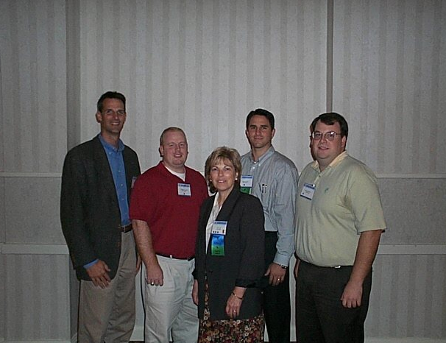

Roanoke ASHRAE Members in Johnstown PA (Sat, Sept 20):
(left to Right) John Mann, Andy Fuller, Pat Cady, Jason Fulop, Chris Beverly

